O range Keystone Tour

Before we begin our tour, let us delve into the research that lead to the sweeping narrations that encompass this tour and the culmination of scholarly research from Quinn Haverstick, Meryl Liu, and Matthew Ciccone, and Aidan Iacobucci. It is our most fervent mission to contextualize the tone of Princeton University campus immediately following World War II and our motive is to gather the literature of this period in history; after all, literature points to the attitude of an era and will make the data that we collect ring much more true. We collected sources through the Papers of Princeton website:

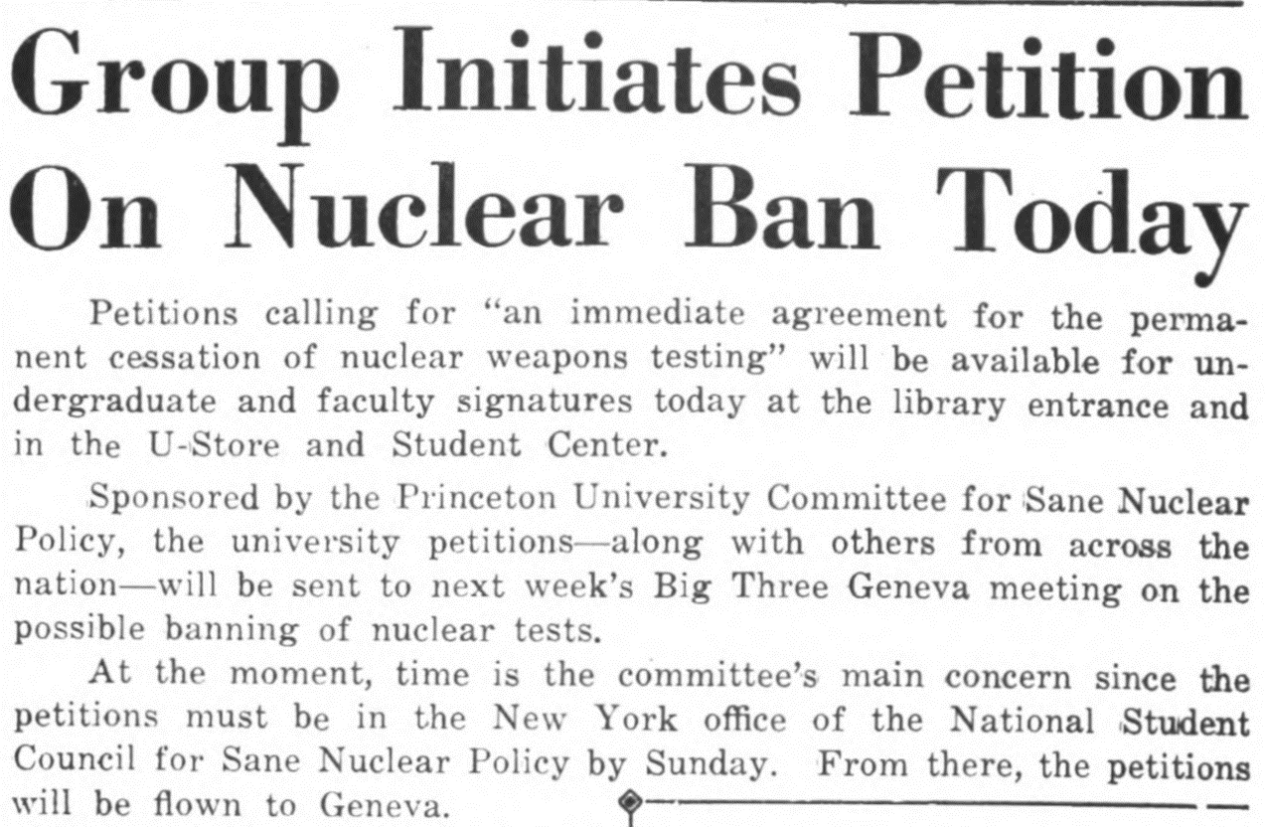
The Daily Princetonian, 1958

Our goal was to establish an omniscient perspective regarding the nuclear ideologies of the Princeton student body as a whole, as well as the opinions of individual Princeton students. We thought it would be fruitful to look at old Daily Princetonian articles to gather a sense of campus sentiment. The above article from 30 October 1958, showcases the undergraduate student body’s denouncement of nuclear weapons and calling for an “immediate cessation of nuclear weapons testing.” This article is important as it casts light on early attempts of nuclear disarmament by virtue of the protests of an incredulous student body. Some more marked connections can be drawn to Dr. Zia Mian and his involvement in the Princeton Program on

Science and Global Security (SGS). The Science and Global Security was founded in 1974 by physicists from Princeton and surrounding universities and is based in the School of Public and International Affairs. One overarching goal of the program is to “conduct scientific, technical and policy research, analysis and outreach to advance national and international policies for a safer and more peaceful world” (Jess Uairas, Slide 7). The SGS was also integral in setting up a Project on Peace and Security in South Asia to emphasize non-proliferation measures across the world and to “Provide independent technical and policy analysis to inform the South Asian nuclear debate and develop policy proposals that could contribute to easing and ending the nuclear confrontation in the subcontinent” (Jess Uairas, Slide 9). Dr. Zia Mian has also been part of documentaries that outline the humanitarian crisis that encompasses the race of nuclear arms. For example, in countries like Pakistan and India, weapons are taking a major economic toll and detracting from each country's fulfillment of basic human needs in exchange for building a nuclear arsenal. This overarching disdain for nuclear weapons from the likes of Mian and the SGS also emphasizes the irony of the University engaging in pro-nuclear practices much to the chagrin of the faculty and students that made up this institution. I also found it quite interesting that there are parallels between the student body then and now: both fight for their respective political beliefs. There is a current referendum that is calling for the boycott of Caterpillar machinery due to their involvement in Israel and death of Palestinian people. This boycott is analogous to the anti-nuclear campaign of Princeton in the 1950s.
The second set of pieces of digital information that we incorporated into our research are two poems submitted to or showcased by the Nassau Literary Review: The Atomic Bomb (1941) and When (undated).

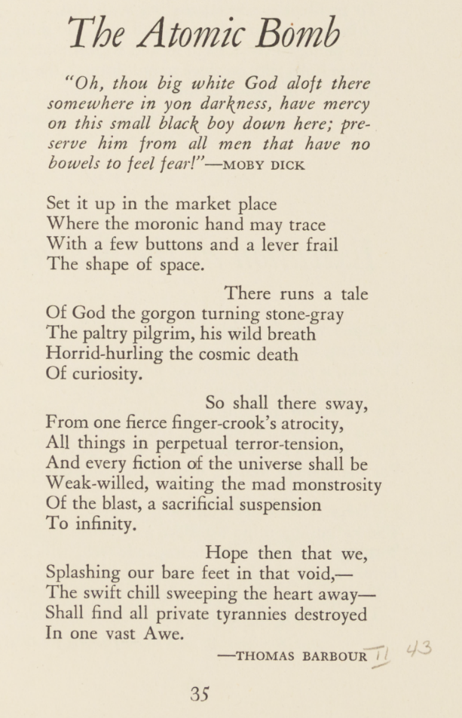 | When  By Sharon Olds  I wonder now only when it will happen,  when the young mother will hear the  noise like somebody's pressure cooker  down the block, going off. She'll go out in the yard,  holding her small daughter in her arms,  and there, above the end of the street, in the  air above the line of the trees,  she will see it rising, lifting up  over our horizon, the upper rim of the  gold ball, large as a giant  planet starting to lift up over ours.  She will stand there in the yard holding her daughter,  looking at it rise and glow and blossom and rise,  and the child will open her arms to it,  it will look so beautiful.

The first poem highlights the magnitude and destruction of nuclear weapons. “With a few buttons and a lever frail the shape of space.” This line in stanza two shows the juxtaposition of minute human ministrations and immense, almost exalted power of the atomic bomb. In addition, the third stanza showcases the “paltry pilgrim” and “his wild breath” galvanizing the death of curiosity. This stanza showcases how humans are infiltrating the established ebbs and flows of naturality; they are obtruding themselves into the unnatural by using scientific strategium to create and justify mass death, ultimately leading to the bane of their existence: the end of human thought and curiosity. It also shows these eurocentric scientists as “pilgrims” alluding to an indirect protest of the colonization of native land. This sentiment can be exemplified in the last line in the poem purporting that “all private companies will be destroyed in one vast Awe” underscores the chief idea that nuclear warfare will inevitably lead to destruction in all sectors, private, governmental, and social. Poetic lines such as these cross cultural divides in literature, as evident in We Have Been Told Many Things But We Know This To Be True by Simon Ortiz. In stanza two of this poem from the anthology Fight Back for the Sake of the People, for the Sake of the Land, Ortiz fervently argues the more important nature of land. Land has a mutual grasp with humans who function as its stewards.

It is what makes for self-reliance,
relying on the relation between land and people.
The people and the land are reliant
upon one another.
This is the kind of self-reliance
that has been—
before the liars, thieves, and killers—
and this is what we must continue
to work for.
By working in this manner,
for the sake of the land and people
to be in vital relation
with each other,
we will have life,
and it will continue. (Ortiz, 35)

This poem goes hand-in with the pragmatism of The Atomic Bomb and its mentions of unfortunate land acquisition. It emphasizes the utter naturality of servicing the land, an instinctual human trait that came far before greed took over. If we can return to the more humanistic approach to appraising the future, “we will have life and it will continue.”
“When,” by Sharon Olds, intersects nuclear tension with a wafting presence of suburban malaise. Instead of driving monotonous mania through a scene of tried-and-true societal tumult, Olds forges a new direction to the poem. Enthrall and release terminate the stanza, but they are

also there to join the indelible and presaging opening question: I wonder now only when it will happen. It is more than just the world coming to a final age, but a kind of thinking about the naturality of the world, as well. Both When, We Have Been Told Many Things But We Know This To Be True, and The Atomic Bomb encapsulate the feelings and attitudes of Princeton students, indigenous scholars, and other institution faculty before and after the implementation of nuclear armament – effectively buttressing the research in this tour.

